**Lab 4 D**

**Exercise 1:** Assign an Intune license to an individual user

The following steps allow you to assign an Intune license to a user:

1. In the [Microsoft Endpoint Manager admin center](https://go.microsoft.com/fwlink/?linkid=2109431), select **Users** > **All Users** > the user's name > **Licenses** > **Assignments**. The **Update license assignments** pane is displayed.
2. Choose the box for **Intune** > **Save**.

The user account now has the permissions needed to use the service and enroll devices into management.

## Assign Intune licenses to multiple users

The following steps allow you to assign Intune licenses to multiple users all at once:

1. Sign in to the [**Azure AD admin center**](https://aad.portal.azure.com/).

**Note**

To manage licenses, the admin account must be a license administrator, user administrator, or global administrator. The account you create using the Intune free trial is a global administrator.

1. Select **Azure Active Directory** > **Licenses** > **All products** to see and manage all licensable products that you have available for your organization.
2. Select the box next to **Intune**.
3. Click **Assign** > **Add users and groups**.
4. If you have created a group of users, click the group to add it to the **Selected items** list. Otherwise, select individual users that you have created earlier. Click **Select** to confirm your selection.

[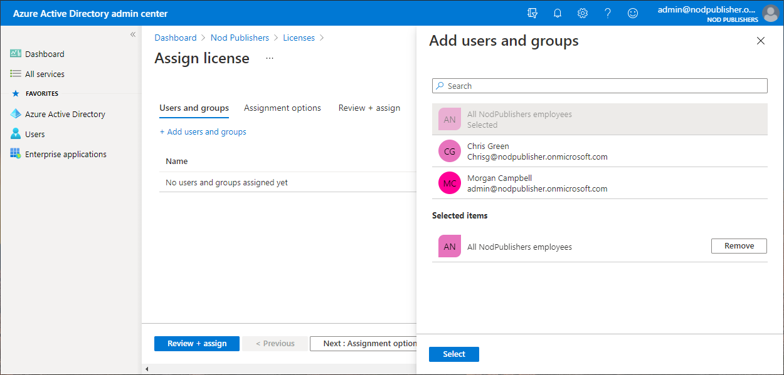](https://docs.microsoft.com/en-us/learn/endpoint-manager/set-up-microsoft-intune/media/sign-up-for-intune-15.png#lightbox)

1. Click **Next: Assignment options** to confirm **Microsoft Intune** is **On**.
2. Click **Review + assign** to confirm your license assignment settings.
3. Click **Assign** to assign the licenses to the selected users.

A notification is displayed in the upper-right corner that shows the status and outcome of the process. If the assignment to the group couldn't be completed (for example, because of pre-existing licenses in the group), you can click the notification to view details.

The user accounts now have the permissions needed to use the service and enroll devices into management.

### **Exercise 2:** Give permissions in Microsoft Endpoint Manager admin center

Because Intune is a part of Microsoft Endpoint Manager, you can add roles using Microsoft Endpoint Manager admin center. To grant permissions, follow these steps:

1. Sign in to the [Microsoft Endpoint Manager admin center](https://go.microsoft.com/fwlink/?linkid=2109431) with a global administrator account > **Users** > **All users** > the user's name. You'll see the user's **Profile**.
2. Select **Assigned roles** > **Add assignments**.
3. In the **Directory roles** pane, select the roles you want to assign to the user.
4. Click **Add**.

### **Exercise 2:** Give permissions in Microsoft 365 admin center

You can also use the Microsoft 365 admin center to add roles. There are a number of additional roles available in the Microsoft 365 admin center that you can use with a variety of Microsoft services. The Microsoft 365 admin center also lets you manage Azure AD roles and Microsoft Intune roles.

**Tip**

To access the Microsoft 365 admin center, your account must have a **Sign-in allowed** set. In the portal under **Profile**, set **Block sign in** to **No** to allow access. This status is different from having a license to the subscription. By default, all user accounts are **Allowed**. Users without administrator permissions can use the Microsoft 365 admin center to reset Intune passwords.

To grant permissions, follow these steps:

1. Sign in to the [Microsoft 365 admin center](https://admin.microsoft.com/) with a global administrator account > select **Users** > **Active users** > choose the user to give admin permissions.
2. In the user pane, choose **Manage roles** under **Roles**.

**Note**

If you don't see a **Roles** section in the user pane, check whether the user has a license in the **Active users** list.

1. In the **Manage admin roles** pane, choose the admin permission to grant from the list of available roles.
2. Click **Save changes**.